Advanced Machine Learning Report

Data Description and Preprocessing
The AutoTrader Car Sale Adverts dataset first underwent a rigorous preprocessing pipeline to handle noise, manage high cardinality, and ensure data leakage-free transformations.

Feature Engineering and Initial Cleaning
The target variable, price, exhibited a heavy right-skew. To stabilise variance and improve model performance, it was log-transformed into the new feature log_price (Figure 1). A new vehicle_age feature was derived by parsing the reg_code and filling missing year_of_registration values, providing a more continuous and predictive metric. Missingness indicators (binary columns representing NaN presences) were generated based strictly on the training set to retain information about data absence without causing data leakage.
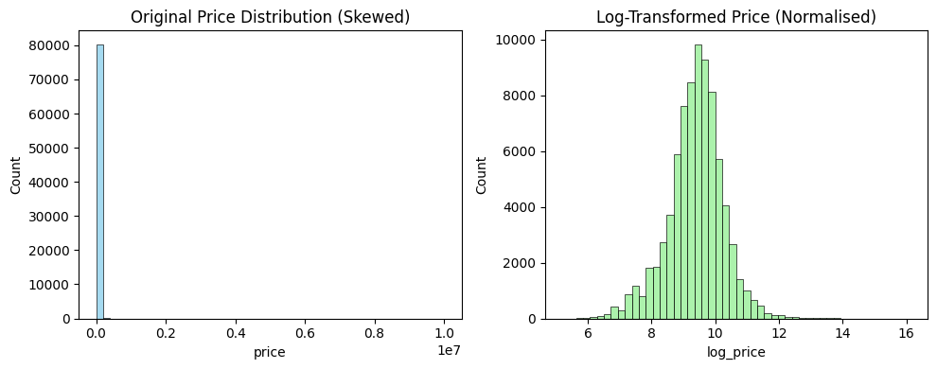
Figure 1 - Price and Log Price Histogram Comparison

Data Partitioning and Imputation
To ensure extensive evaluation and prevent data leakage, the data was partitioned into Train (60%), Validation (20%), and Test (20%) sets prior to any transformations. Numerical features were imputed using the median, while categorical features used the mode (most frequent). To mitigate the impact of extreme outliers, numerical features were clipped at the 1st and 99th percentiles based on the training distribution.

Categorical Encoding and Scaling
Categorical features were split based on cardinality to optimise computational resources:
- Low Cardinality (< 20): Rare categories (appearing <1% of the time) were grouped into an 'Other' category to reduce noise, followed by One-Hot Encoding (OHE).
- High Cardinality (> 20): Variables such as car make and model were processed using Target Encoding (with a smoothing factor of 10.0). This successfully reduced large, sparse feature matrices into simpler, more informative numeric features.
Finally, all non-binary numerical features were standardised using a StandardScaler.

Final Output Dataset
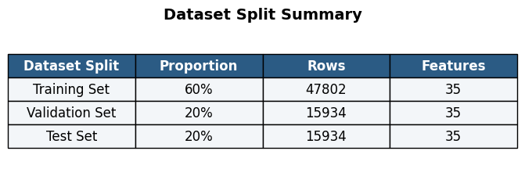
The final, fully transformed data structure (Table 1) used as the input for all subsequent machine learning tasks consists of 35 engineered features.

Table 1 - Preprocessing Output Dataset Summary Table

Automated Feature Selection
To isolate the most predictive variables, reduce the dimensionality of the dataset, and mitigate the risk of overfitting, two distinct automated feature selection methods were applied and compared: Recursive Feature Elimination with Cross-Validation (RFECV) and Sequential Feature Selection (SFS).
Both methods utilised a LinearRegression base estimator. While tree-based algorithms can capture non-linear relationships, Linear Regression was chosen here to significantly reduce computational time. To ensure robust validation, both methods were evaluated using 5-fold cross-validation, optimising for the $R^{2}$ scoring metric.

RFECV (Recursive Feature Selection with Cross Validation)
RFECV evaluated dropping one feature at a time. It achieved an optimal cross-validated $R^{2}$ score of roughly 0.86, selecting 28 features. However, as shown in the performance plot (Figure 2), the model's accuracy sharply plateaus after approximately 6 to 8 features. The selection of 28 features highlights RFECV's tendency to retain features that offer only minimal, gains to the absolute score.
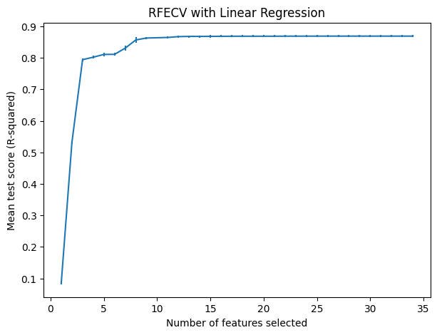

Figure 2 - RFECV Error Bar Plot

SFS (Sequential Feature Selection)
To contrast this, SFS was implemented with a stopping tolerance of (tol=0.005). This mandated that a new feature must improve the $R^{2}$ score by at least 0.5% to be included. SFS successfully identified a highly condensed subset of just 6 features.

Feature Selection Evaluation
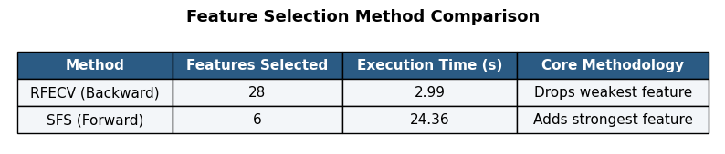
The SFS results validate the visual plateau in the RFECV plot: a computationally cheaper, 6-feature model can achieve nearly identical predictive power to a 28-feature model. The 6 common features shared by both methods represent the primary drivers of vehicle price. However, to provide maximum information to the more complex, non-linear Tree Ensembles in the subsequent tasks, the bigger subset of 28 features identified by RFECV will be used in the subsequent tasks.

Table 2 - Feature Selection Method Comparison

Tree Ensembles
To capture the complex, non-linear relationships within the dataset, two tree-based ensemble models were trained, tuned, and evaluated: a Random Forest Regressor and a Gradient Boosting Regressor. Both models were trained using the 28 features identified during the RFECV automated feature selection phase.

Hyperparameter Tuning
An iterative approach was taken for hyperparameter tuning to effectively manage computational load. Initial grid searches resulted in parameters hitting the upper bounds of the specified grids. To ensure model performance was not artificially capped, the parameter grids were subsequently expanded allowing up to 400 estimators and deeper maximum depths. Using 3-fold GridSearchCV optimising for $R^{2}$, the models were able to find an optimal balance of complexity without maximising every bounded parameter.

Model Evaluation
To ensure the evaluation is easily interpretable, predictions were transformed from log transformed values back to actual numerical prices (np.expm1) to calculate the Mean Absolute Error (MAE) in pounds (£).
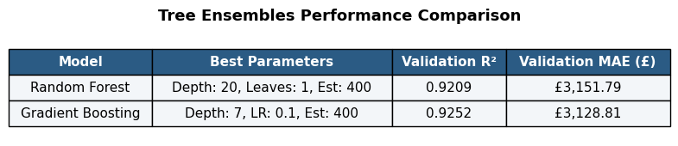

Table 3 - Performance metrics and optimal hyperparameters for tuned Tree Ensembles

Both models performed exceptionally well, explaining over 92% of the variance in the validation set. However, the Gradient Boosting model emerged as the superior estimator. By building trees sequentially to correct prior residual errors, it achieved a higher $R^{2}$ (0.9252) and a lower MAE (£3128.81), beating the Random Forest's error by approximately £23 per vehicle.

Impurity-Based Feature Importance
To understand the Random Forest's decision-making process, the built-in Gini impurity-based feature importances were extracted and plotted (Figure 3).
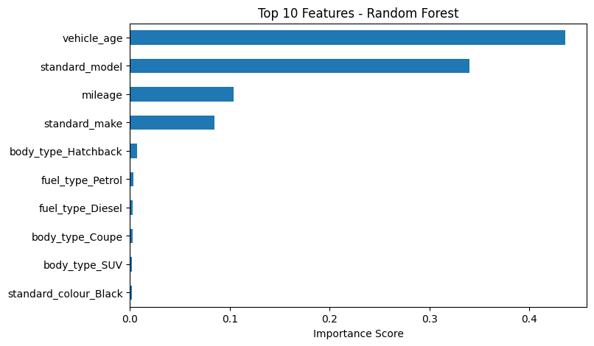
The graph indicates that vehicle_age and standard_model are overwhelmingly the most dominant features for node splitting. However, a critical limitation of impurity-based importance is its inherent bias toward continuous and high-cardinality categorical variables. Because variables like age and specific car models offer significantly more potential split points than binary flags like body_type_Hatchback, their apparent importance may be inflated here. This limitation requires the use of more robust, model-agnostic explanation techniques.
Figure 3 - Random Forest Feature Importances

Ensemble of Tree Ensembles
To further enhance prediction accuracy and reduce model variance, an "ensemble of ensembles" approach was implemented. This strategy combines the predictive power of the two highly tuned models developed in the previous task: the Random Forest (a bagging ensemble) and the Gradient Boosting Regressor (a boosting ensemble).

Ensembles

Voting Regressor
A simple averaging ensemble that takes the mean of the predictions from the Random Forest and Gradient Boosting models. This approach relies on the principle that averaging multiple independent errors tends to zero, yielding a more robust aggregate prediction.

Stacking Regressor
A meta-learning approach where the predictions of the base models are fed as inputs into a final estimator. A RidgeCV regressor was utilised as the meta-learner, combined with 5-fold cross-validation (cv=5) to prevent data leakage and overfitting during this phase.

Results
Both ensembles were evaluated on the validation set using the $R^{2}$ and MAE (£) metrics.


Table 4 - Ensembles of Ensembles Performance Table

As shown in Table 4, both ensemble methods successfully outperformed the best individual base model (Gradient Boosting), supporting the main concept behind combining multiple models.
The simpler Voting Regressor achieved the highest $R^{2}$ (0.9274) and the lowest MAE (£3,061.99), outperforming the more complex Stacking Regressor. This outcome is expected when combining optimised, highly correlated tree ensembles. Because the Random Forest and Gradient Boosting models were already tuned to their near-optimal capacities on the exact same features, their individual predictions were likely very similar. Here, the simple averaging mechanic of the Voting Regressor acted as a highly effective regulariser. Conversely, the RidgeCV meta-learner in the Stacking architecture may have struggled to find a significantly better linear combination of these highly correlated predictions, introducing slight complexities without yielding predictive gains.
The Voting Regressor successfully reduced the average prediction error by an additional £66 per vehicle compared to the baseline, confirming it as the strongest predictor in the pipeline.

Feature Importance
While the Tree Ensembles achieved high accuracy, their built-in impurity-based feature importances are inherently biased toward continuous variables or categorical features with high cardinality. To obtain a true, unbiased understanding of the Gradient Boosting model's decision-making logic, two model-agnostic techniques were applied: Permutation Importance and Shapley Additive ExPlanations (SHAP).

Permutation Importance
Permutation importance measures how much the model's performance ($R^{2}$score) degrades when a single feature's data is randomly shuffled, effectively destroying its relationship with the target variable.
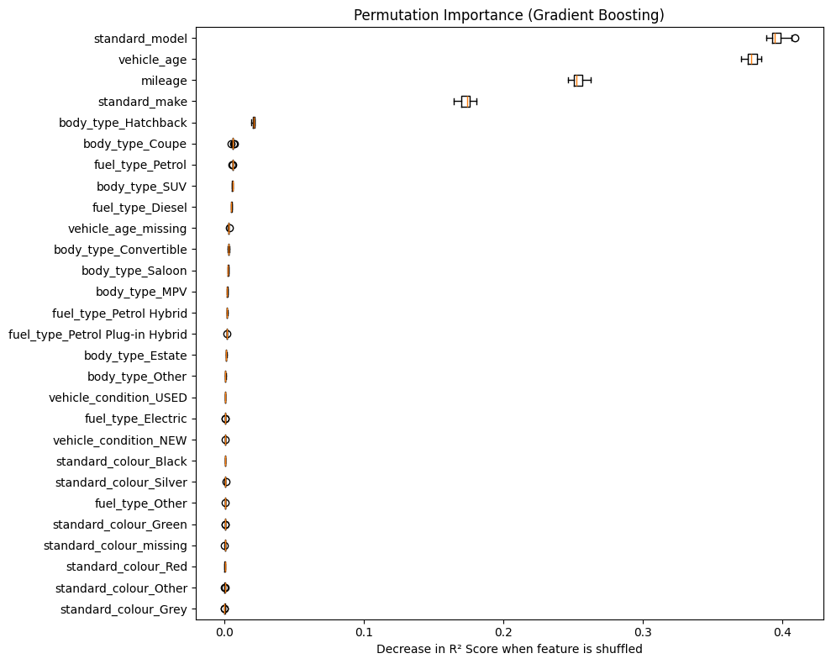
Figure 4 - Permutation Importance Gradient Boosting Graph
Figure 4 reveals the true hierarchy of the dataset. While the model was given 28 features, it is primarily driven by only four core attributes. Shuffling the standard_model feature causes a massive roughly 0.40 drop in the $R^{2}$ score (a nearly 40% loss in predictive power). This is closely followed by vehicle_age, mileage, and standard_make. The steep drop-off after these top four indicates that the remaining 24 features (such as specific fuel types or body styles) provide only fractional, marginal refinements to the final price prediction.

SHAP
While Permutation Importance shows how much a feature matters, it does not show how it affects the prediction. SHAP values solve this by calculating the marginal contribution of each feature to every individual prediction in the validation set.
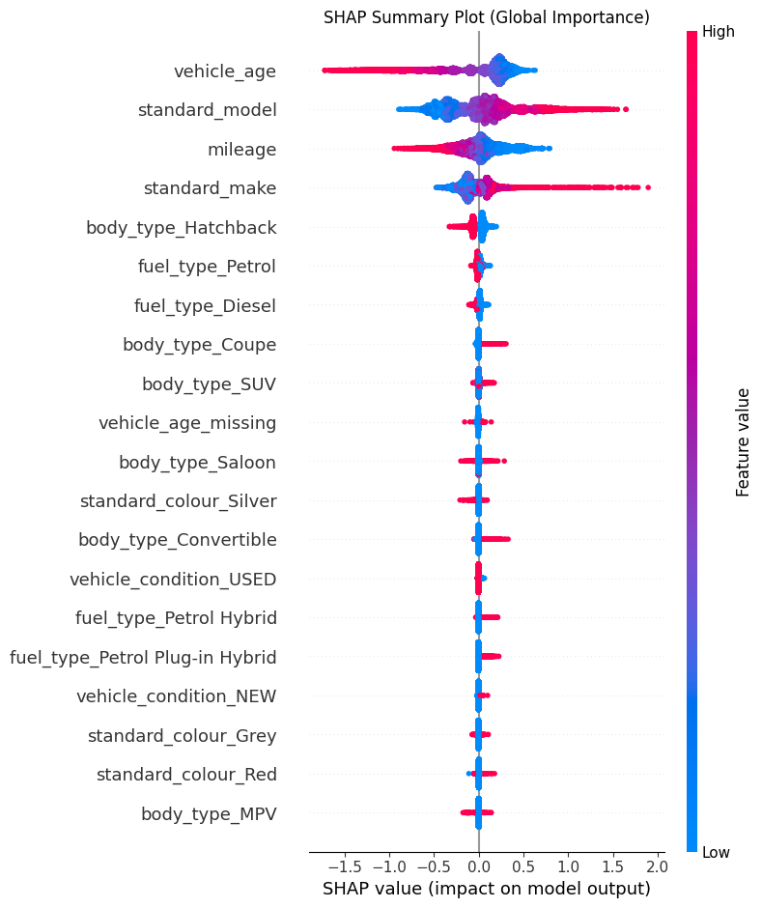

Figure 5 - SHAP Summary Plot
The SHAP summary plot (Figure 5) visualises how the model makes its decisions:
- Age and Mileage: Looking at vehicle_age and mileage, high feature values are distinctly clustered on the left side of the zero-axis. This confirms the model correctly learned car depreciation: older cars with higher mileage drive the predicted log-price down.
- Make and Model: Conversely, looking at standard_model and standard_make, high feature values stretch far to the right, heavily increasing the predicted price. Because these features were Target-Encoded in Task 1, a "high" value represents a luxury car. The model successfully correlates these high-tier encoded values with premium price tags.
By using SHAP and Permutation Importance, I removed the built-in biases of tree models and clearly show that the model matches real market trends in car pricing.

SHAP/PDP Model Explanations
While global feature importance identifies which variables drive the model overall, it is beneficial to understand how these features affect individual predictions. To achieve this, SHAP Local Explanations and Partial Dependence Plots (PDP) were implemented using the tuned Gradient Boosting Regressor.

SHAP Waterfall Plot
A SHAP Waterfall plot (Figure 6) was used to break down the exact decision-making process for a single instance in the validation set (Index 0).
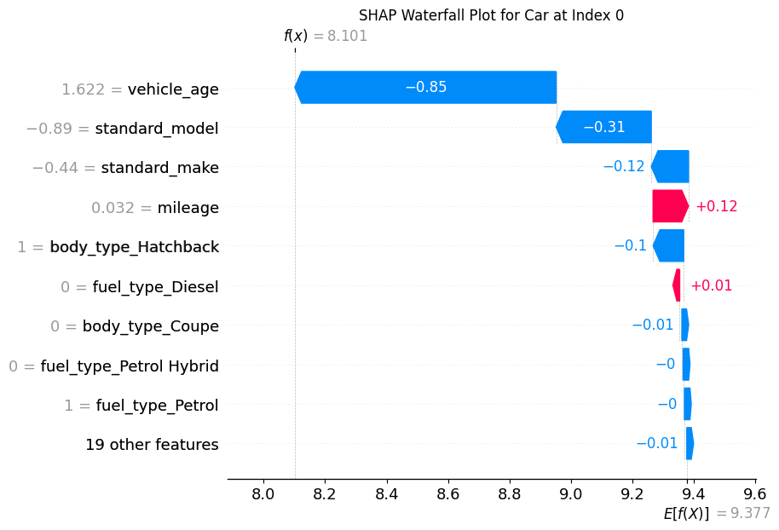
The plot illustrates how the model arrives at its final prediction starting from the baseline. The expected average prediction across the entire dataset ($E\left[f\left(X\right)\right]$) is a log-price of 9.377 (approx. £11,800). However, the model predicts a final log-price of 8.101 (approx. £3,300) for this specific vehicle.
Figure 6 - SHAP Waterfall Plot for Car[0] in Validation Set
The waterfall plot clearly explains this steep discount:
- Age: This car is significantly older than average (standardised vehicle_age = 1.622). This single feature drags the predicted log-price down by -0.85.
- Make and Model: The car belongs to a lower-tier brand and model category (represented by negative standard scaled values of -0.89 and -0.44), which further reduce the price by -0.31 and -0.12, respectively.
- Mileage: The vehicle's mileage is near the dataset average (0.032), which actually provides a slight increase of +0.12 compared to the baseline expectation.

Partial Dependence Plot (PDP)
To complement the local SHAP explanation, Partial Dependence Plots (Figure 7) were also implemented to show the global effect of the top two features on the predicted log-price, assuming all other features remain constant.
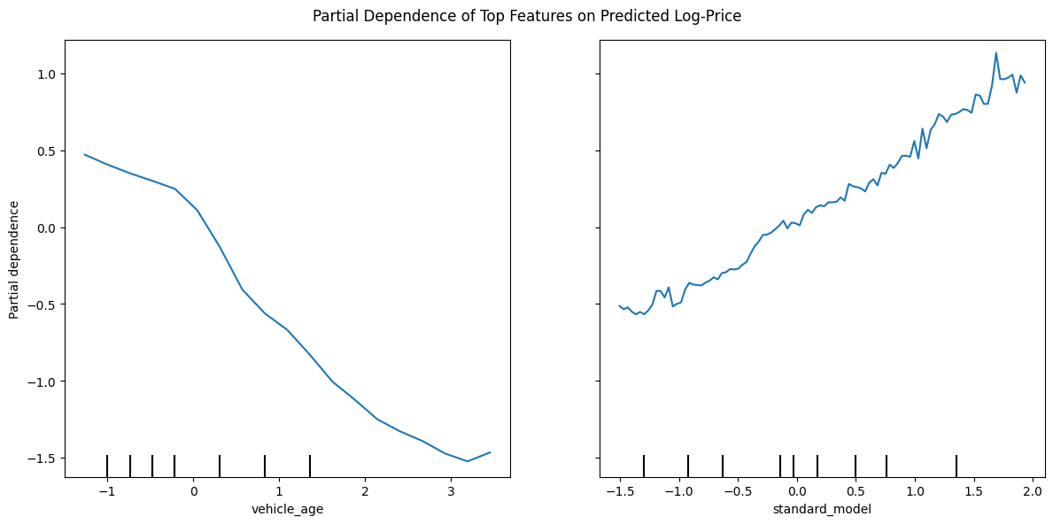
Figure 7 - PDP of Age and Model on Log Price
The PDPs validate the model's economic logic:
- Vehicle Age: The plot reveals clear downward trend. As the standardised age of the vehicle increases, the model's predicted base price reliably drops, perfectly mapping real-world car depreciation.
- Standard Model: Because standard_model was target-encoded during preprocessing, the x-axis represents the encoded historical value of the model (budget models on the left and premium models on the right). The PDP exhibits a linear relationship, proving that the Gradient Boosting model correctly scales the predicted price upward as the categorical "status" of the car increases.
Together, these plots show that the model understands the real factors that affect used-car prices.

Liner Dimensionality Reduction
To combat the curse of dimensionality, reduce computational overhead, and identify hidden linear relationships within the dataset, Principal Component Analysis (PCA) was applied. Unlike feature selection which drops variables entirely, PCA projects the fully scaled, 34-feature dataset onto a new set of orthogonal axes (Principal Components) that capture the maximum variance of the original data.
A full PCA was initially fit to evaluate the explained variance ratio of every possible component.
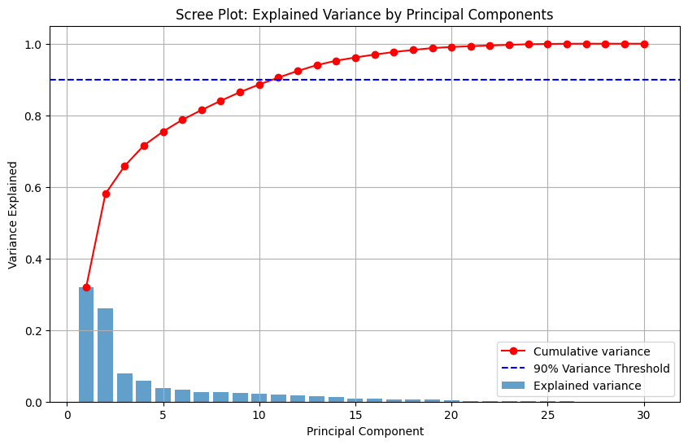
Figure 8 visually demonstrates a sharp elbow after the first three components, indicating that most of the important information in the dataset is captured by only a few linear combinations. Rather than hardcoding an arbitrary number of components, a dynamic threshold was set to retain 90% of the cumulative variance.
Figure 8 - Scree Plot of Explained Variance by Principal Components
The algorithm determined that exactly 11 Principal Components were required to cross this 90% threshold.
Table 5 - Summary of Dataset after PCA
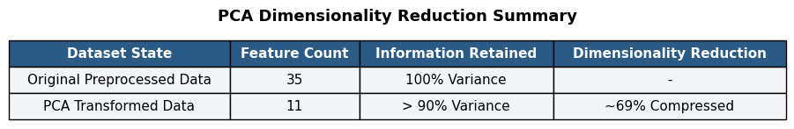

As shown in Table 5, PCA successfully compressed the dataset's dimensionality by roughly 69%, from 34 features down to 11, while sacrificing less than 10% of the variance. This tighter, denser matrix is highly beneficial for distance-based algorithms and significantly reduces model training times.
However, this mathematical efficiency comes at the cost of interpretability. While the original features (vehicle_age, mileage) were easily explainable, as demonstrated via SHAP, the new Principal Components are abstract linear combinations of all 34 variables. "PC1" cannot be translated into a real-world concept, meaning PCA transformed a highly interpretable model into a black box. Therefore, while PCA can improve model performance, it isn’t suitable when clear model explanations are needed.

Non-Linear Dimensionality Reduction
While PCA successfully extracted linear variance, it inherently fails to capture complex, non-linear structures within data. To discover these hidden manifolds, two non-linear dimensionality reduction techniques were implemented: Isomap and t-Distributed Stochastic Neighbor Embedding (t-SNE).

Computational Constraints
Unlike PCA, manifold learning algorithms are computationally expensive, particularly Isomap's requirement to compute a geodesic distance matrix. To ensure computational feasibility and reasonable execution times, a random subset of 5,000 observations was sampled from the fully processed training data for this phase. Both algorithms were configured to project the 34-dimensional feature space down into a 2-dimensional visual space.

Global vs. Local Structure
The side-by-side visualisations (Figure 9) reveal deeply distinct interpretations of the dataset's underlying shape:
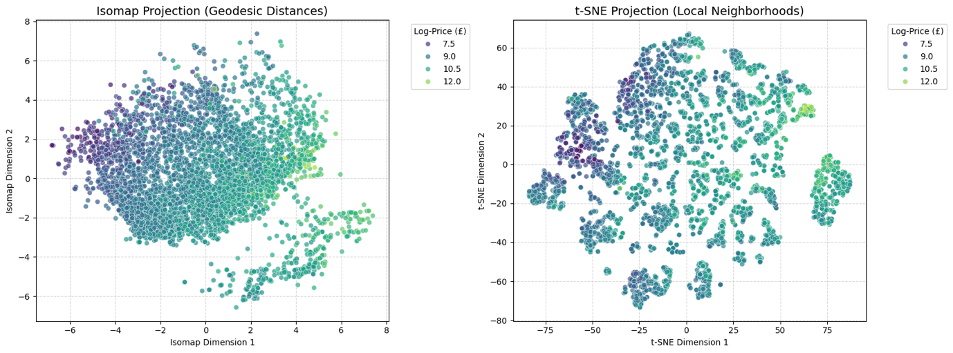
Figure 9 - Plot Comparison Isomap and T-SNE

Isomap (Global Structure)
Isomap seeks to preserve the global geodesic distances between all points. The resulting projection demonstrates a continuous spatial gradient. Vehicles with lower log-prices (dark purple) cluster heavily on the left, seamlessly transitioning into mid-range vehicles (teal), and finally spreading into high-value vehicles (light green/yellow) on the far right. The algorithm successfully ordered the cars by economic value purely by assessing their feature geometries, without explicitly being trained to predict the price.

t-SNE (Local Structure)
t-SNE prioritises preserving local neighborhoods, often tearing the global manifold to cluster similar points together. This plot reveals distinct, isolated "islands" of data. Notably, the most expensive vehicles (yellow/light green) are heavily isolated into specific clusters on the edges of the projection. This indicates that high-end vehicles share specific local feature similarities (e.g. specific luxury makes combined with low ages) that distinctly separate them from the majority cheaper cars.

Analysis
While these algorithms are exceptionally powerful for Exploratory Data Analysis (EDA), they possess severe limitations. They cannot be easily scaled to the full 400,000+ row dataset due to memory and time constraints. Furthermore, t-SNE lacks a parametric mapping function, meaning it cannot reliably project new, unseen test data into the existing space. Therefore, while highly informative, these methods are better suited for analysis rather than acting as actual preprocessing steps in the final pipeline.

Polynomial Regression
To explore non-linear modelling outside of tree-based ensembles, a Polynomial Regression was implemented. Rather than using the full feature set, this model was strictly univariate, focusing solely on the vehicle_age feature to isolate and map its continuous, non-linear relationship with price.

Bayesian Regression
To introduce a degree of model confidence, the features were transformed to a 3rd-degree polynomial space and passed into a BayesianRidge estimator. Unlike standard Ordinary Least Squares (OLS) regression, which only outputs a single mean prediction, Bayesian regression estimates a full probability distribution, allowing for the extraction of credible intervals.
Table 6 - Performance Metrics for Bayesian Regression
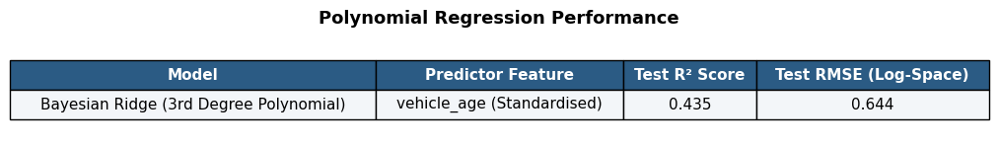
As shown in Table 6, this single-feature model achieved a Test $R^{2}$ of 0.435. While this is lower than the Tree Ensembles (which scored ~0.92 using 28 features), explaining 43.5% of the variance in the entire dataset using nothing but the age of the vehicle is a extremely strong result. It acts as secondary validation of the Permutation Importance findings from Task 5, confirming age as a dominant, fundamental driver of value.

Bayesian Polynomial Plot
To evaluate the model's behaviour, a random sample of 1,000 observations was plotted against the Bayesian mean fit and its 95% credible interval.

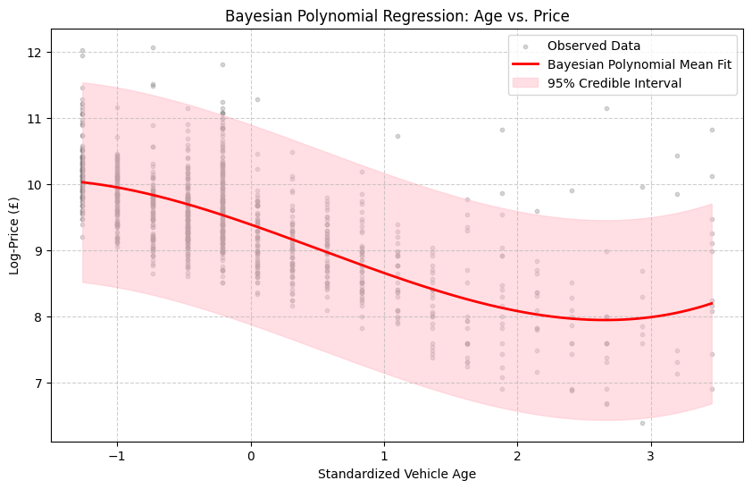
The plot (Figure 10) highlights several critical insights into the advantages and disadvantages of this approach.
Figure 10 - Bayesian Polynomial Regression Plot
The pink 95% credible interval correctly widens at the extreme left (new cars) and extreme right (very old cars). The Bayesian model clearly shows uncertainty in regions where training data is sparse, providing highly valuable transparency.
At the extreme right of the curve (Standardized Age > 3.0), the red mean fit line goes suddenly upward. This implies that 20-year-old standard vehicles begin rapidly appreciating in value. This happens because higher degree polynomials often behave unpredictably at the edges of data. Tree-based models avoid this issue because their predictions stay flat at the edges, making them safer when estimating values outside the training range.

10. Clustering for feature engineering
To extract non-linear spatial interactions and provide predictive models with engineered market segments, K-Means clustering was applied. Rather than clustering on all 34 original features, which would suffer from the curse of dimensionality and dilute the distance metrics, the clustering was strategically restricted to the top three drivers of value identified by the SHAP analysis in Task 6: vehicle_age, standard_model, and standard_make.
The K-Means algorithm was initially iterated across a range of k values (2 to 10) to calculate the Within-Cluster Sum of Squares (WCSS) inertia.
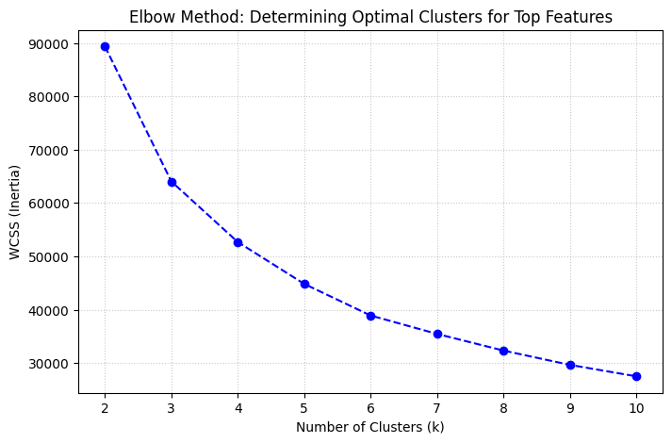
Figure 11 - elbow Plot Determing Optimal Clusters for Top Features

Figure 11 demonstrates a significant plateau in the reduction of inertia starting at k=4. Balancing mathematical variance reduction with interpretability, an optimal k of 4 was selected.
To prevent data leakage, the final K-Means algorithm was fitted strictly to the training data. The validation and test sets were subsequently mapped to these defined centroids using the .predict() method. To evaluate the logic of the algorithm, the training clusters were plotted across the two primary dimensions: Age and Encoded Make.
Figure 12 - K-Means Scatter Plot
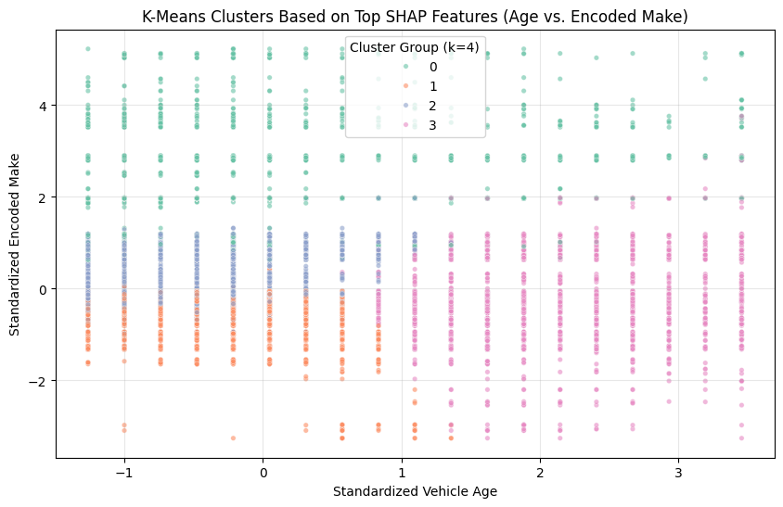
The scatter plot (Figure 12) reveals that the algorithm successfully discovered highly distinct, real-world car market segments purely through spatial distances, without seeing the target price variable.
Table 7 - Business Interpretation of the Derived Clusters
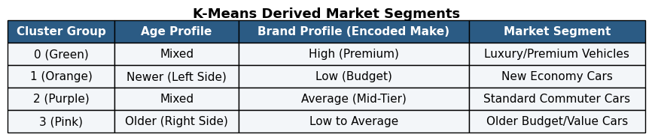
As detailed in Table 7, the algorithm naturally segregated the market into Luxury (Cluster 0), New Economy (Cluster 1), Standard Commuter (Cluster 2), and Older Value (Cluster 3) profiles. This newly engineered categorical feature (shap_cluster_group) was appended to the final preprocessed datasets. By explicitly defining these underlying market geometries, future predictive models can potentially leverage this feature to shortcut complex feature interactions, validating clustering as a highly effective feature engineering methodology.

